- Data structures, coordinates of the illumination pattern and code for in-situ PSF
For data structures, in SMILE, we store the raw data in multiple TIFF stacks, with each stack containing 30,000 image frames (corresponding to 30,000 / 6 = 5,000 SMILE raw frames), arranged in the illumination sequence of x1, x2, x3, y1, y2, y3. Users can adjust the number of raw image frames contained in each stack according to their own system configuration, provided that the number is a multiple of SMILE raw frame.
Fig. 1.1 tiff stacks in the raw data folder

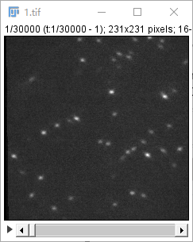
Fig. 1.2 First stack shown in ImageJ

The definition of the coordinate system for the illumination patterns is a critical component of the code. Discrepancy between the actual order of the data sub-images and the specified convention will lead to errors in stripe estimation and reconstruction. We define the row direction as the positive direction of the x-stripes and the column direction as the positive direction of the y-stripes, where the positive direction refers to the direction in which the phase increases by 2π/3 each time.
However, it is also acceptable if the user's phase-shifting direction and sub-image order differ from our specifications. For example, while our defined order is x1, x2, x3, y1, y2, y3, the user’s data may follow an order such as x3, x2, x1, y3, y2, y1, or y1, y2, y3, x1, x2, x3. In such cases, users only need to manually adjust the sub-image order during the sliding window step to align with our specifications.
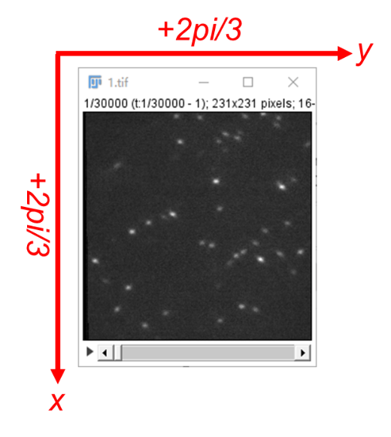
Fig. 1.3 Pattern coordinates

While for the code for in-situ PSF retrieval (VISPR), users can download from https://github.com/ZJUOPTKuangLab/VISPR. Also refer to our paper:
Xinxun Yang, Hongfei Zhu, Yile Sun, Hanmeng Wu, Yubing Han, Xiang Hao, Cuifang Kuang, and Xu Liu, "Accurate 3D single-molecule localization via vectorial in situ point spread function retrieval and aberration assessment," Photon. Res. 12, 2447-2461 (2024)
Users can also choose uiPSF from https://github.com/ries-lab/uiPSF as an alternative.

- Shared Files and File Descriptions
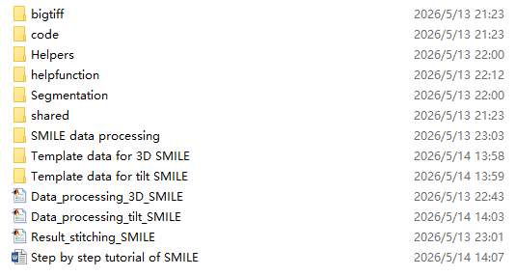
Fig. 2.1 Shared files
‘Data_processing_3D_SMILE.m’ is the reconstruction code for 3D-SMILE mode and ‘Data_processing_tilt_SMILE.m’ is the reconstruction code for tilt-SMILE mode. They are almost the same while existing very small modifications.
‘Template data for 3D SMILE’ and ‘Template data for tilt SMILE’ folders contain the in-situ PSF (in ‘psf’ folder) and one tiff stack raw data (in ‘raw’ folder). The datasets can be downloaded from figshare at https://doi.org/10.6084/m9.figshare.32288076.
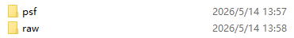
Fig. 2.2 Folders in shared template data

Other folders contain the dependencies required for running the code.

- Step by step tutorial on tilt-SMILE code for example
We use ‘Data_processing_tilt_SMILE.m’ as an illustrative example to facilitate a clearer understanding of the underlying logic of SMILE.

  - read in-situ PSF and set PSF parameters
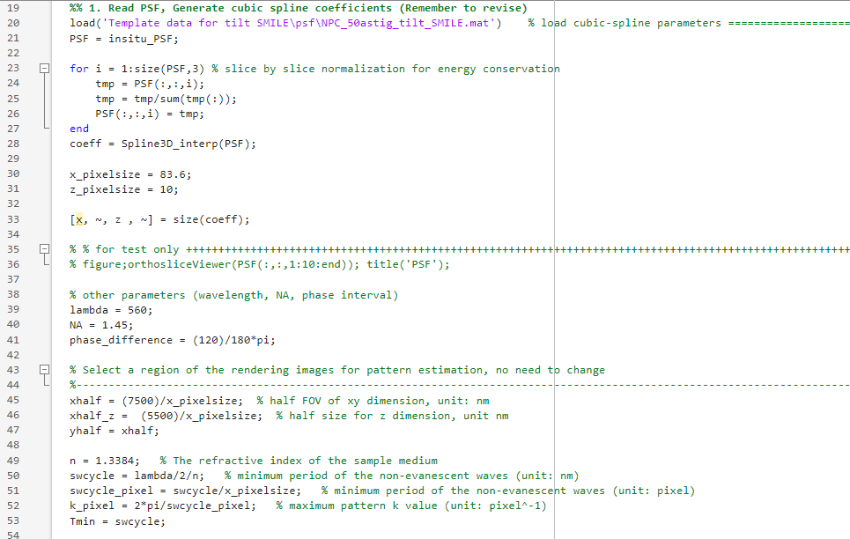

Remember to revise the following parameters:
Line 20, the file path of the in-situ PSF.
Line 30-31, the lateral and axial pixel size of the PSF.
Line 39-40, the excitation wavelength and NA.
Line 49, the RI of the sample medium.
Other parameters can leave unchanged.

  - read raw data for illumination parameter estimation and sliding window
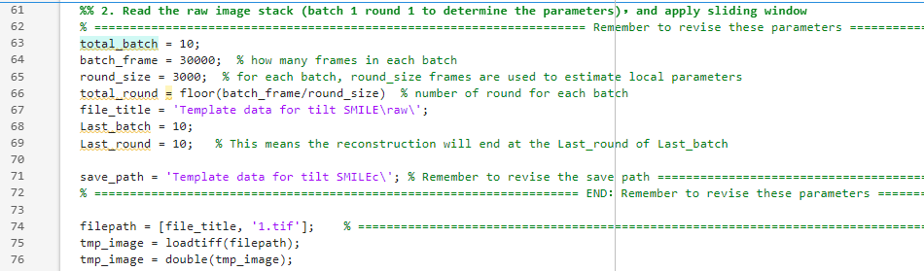
In SMILE, we further divide each stack into multiple rounds for processing, with each round handling 3,000 or 6,000 raw frames to compensate for the drift of stripe parameters. Users need to revise the total_batch (the total number of tiff stacks), batch_frame (the frame number in each tiff stack), round_size (how many frames in each round) and so on (Line 63-69). One can just set Last_batch equal to total_batch and Last_round equal to total_round.

Also revise the save path of the reconstruction results (line 71).

Line 86 – Line 157 is the processing of sliding window strategy. As mentioned in Section 1, if the user's sub-image order differs from our specified convention, adjustments can be made during the sliding window step. See the following code where we stitch all the sliding frames together.
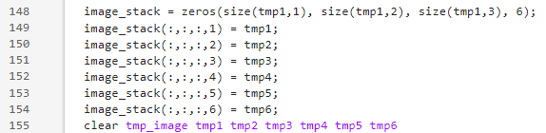

if the user’s order is y1, y2, y3, x1, x2, x3, then replace the code with
image_stack(:,:,:,1) = tmp4;
image_stack(:,:,:,2) = tmp5;
image_stack(:,:,:,3) = tmp6;
image_stack(:,:,:,4) = tmp1;
image_stack(:,:,:,5) = tmp2;
image_stack(:,:,:,6) = tmp3;

if the user’s order is x3, x2, x1, y3, y2, y1, then replace the code with
image_stack(:,:,:,1) = tmp3;
image_stack(:,:,:,2) = tmp2;
image_stack(:,:,:,3) = tmp1;
image_stack(:,:,:,4) = tmp6;
image_stack(:,:,:,5) = tmp5;
image_stack(:,:,:,6) = tmp4;

if the users change the above code, remember also revise the corresponding part in ‘process_round_data.m’ function in line 1519, which is used for processing the tiled data.
If the users are not very sure of the image order, then users can refer to Section 3.4 to determined x/y order and Section 3.6 to determined phase shifting order.

  - segmentation
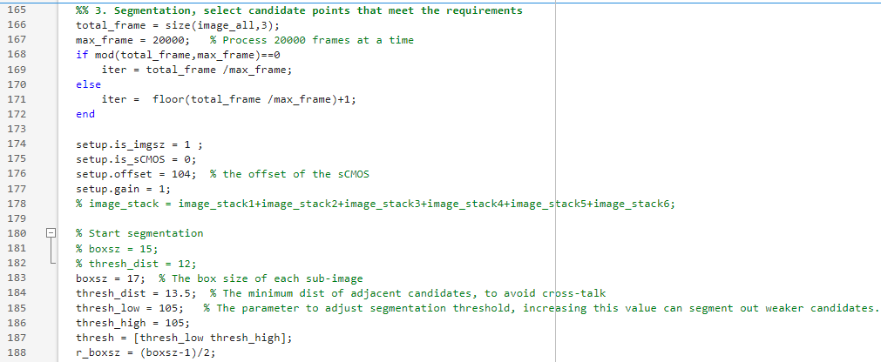
Revise the parameter in line 176, line 183-186. The code will give the segmentation results of one frame and also the segmented candidates. The user can alter the parameters in line 183-186 to change the segmentation threshold. Please refer to the annotations provided in the code to make targeted parameter modifications.
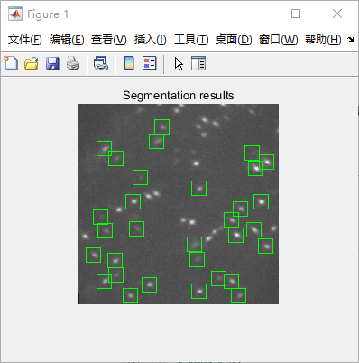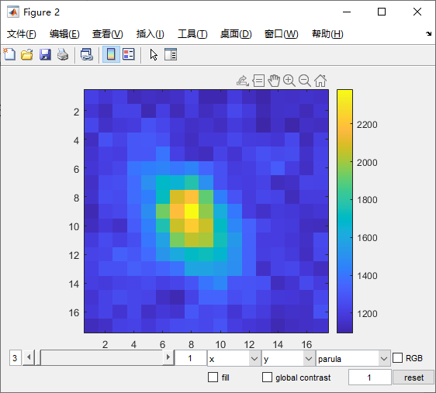

  - ratiometric fitting and initial estimation of pattern parameters
Line 243-297 we perform ratiometric fitting of the segmented candidates to get the photon number of each sub-image. Then we generate photo-weighted rendering to estimate azimuthal angle and tilt angle of the illumination patterns.
The following is the Fourier domain of lateral rendering images, users can check whether the first 3 sub-images are along x direction and the last 3 sub-images are along y direction. If not, users can adjust the order in Line148-154.
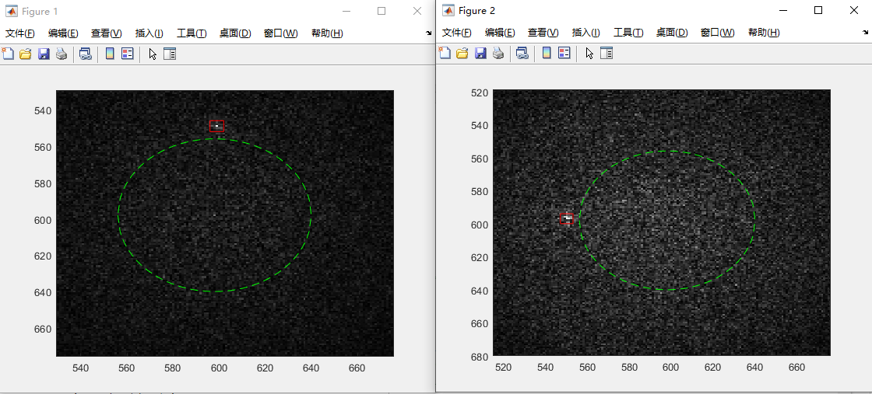

And the following is the Fourier domain of the xz/yz rendering images,
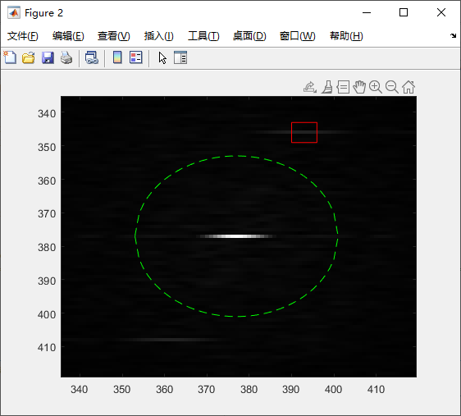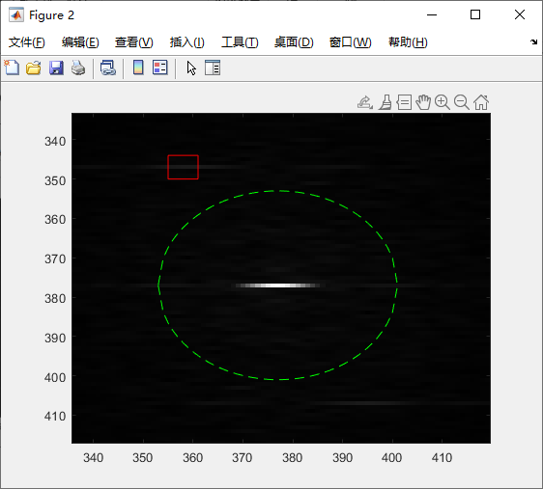

  - filter out sub-optimal candidates and manually refine the pattern parameter
As described in Methods part, we apply additional filters to reject the candidates that do not stay on-state in all six sub-images. The following is set lower and upper bound for normalized intensity for each sub-images in x or y,
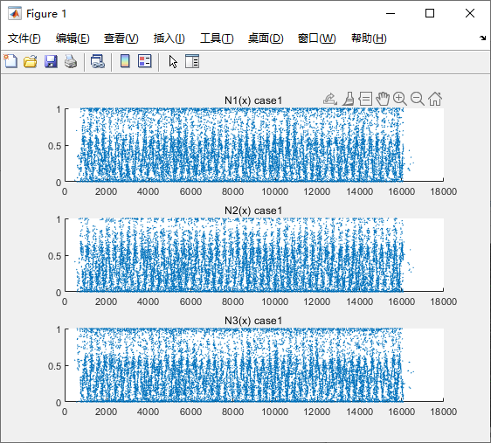
Typically, the upper value is selected as 85% and the lower one is selected as 0%, enter the upper and lower value into the command line as follows，

We have also incorporated a manual parameter refinement function. The following example illustrates the refinement of stripe orientation. Users adjust the slider to maximize the sharpness of the stripe profile, and then input the corresponding value into the command line.
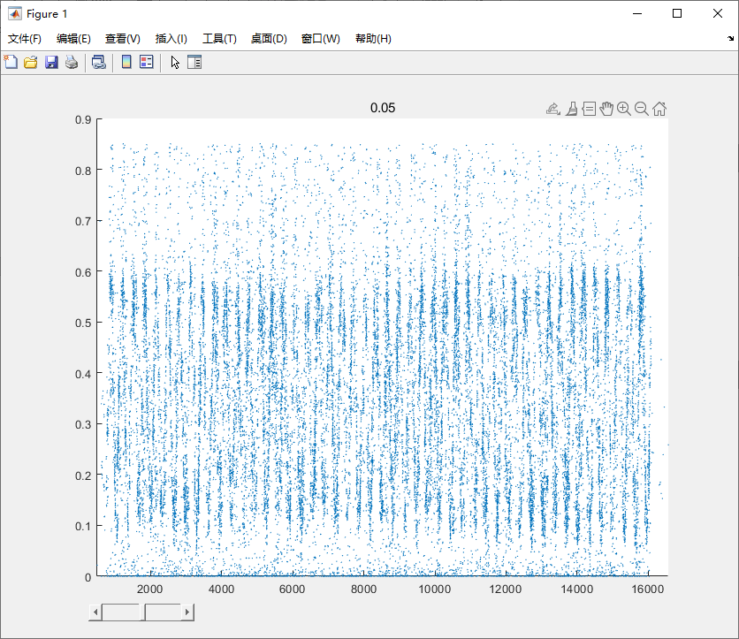

Similar manual parameter refinement function is applied to pattern period too. Adjust the sliders to maximize the sharpness of the stripe profile and input the value.
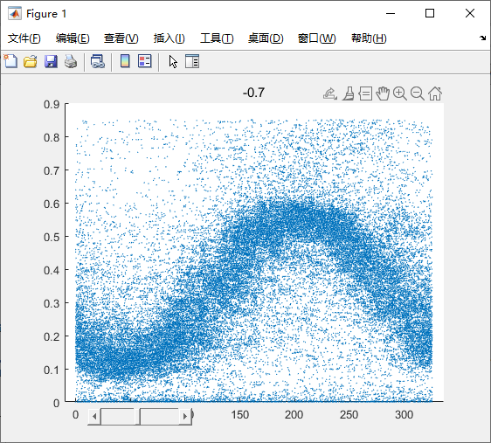

One can just skip the manually adjustment step by directly inputting 0 into the command line.

  - refinement of the pattern parameter by least squared fitting and estimation on global phase
This is the last step toward the final pattern parameters.
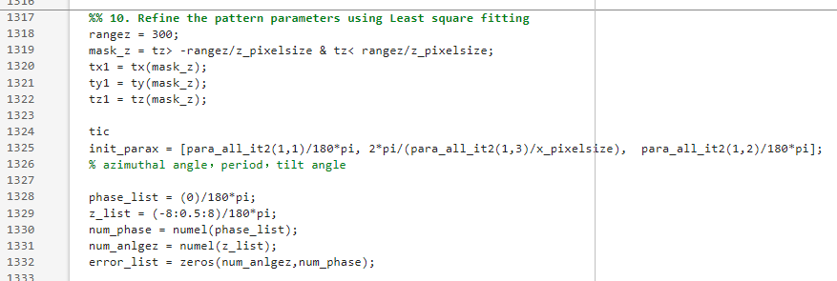

If the image order if not (x1, x2, x3) or (y1, y2, y3), then when you change the rangez from 300 to 200 or 150, the global phase will change greatly. This can be a reference step to check whether the image order is correct.

  - Tiled processing
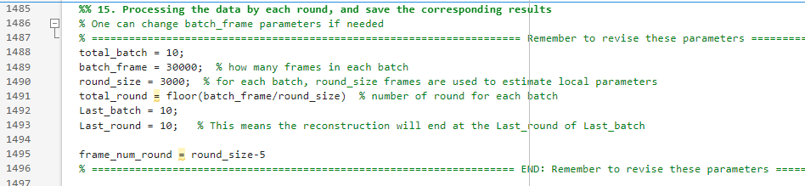
One can still alter the batch and tiled parameters to change the round size. Then all the results will be generated automatically.

  - Stitching the results and convert to SMAP
Use ‘Result_stitching_SMILE.m’ to stitch all the results together and use ‘smile2smap.m’ in ‘SMILE data processing’ folder to convert the stitched results to SMAP style.

